Topic: Introduction to Database

Lecture Session - 1
- Define the terms: Data, Information, Database (DB), Database Management Systems (DBMS)
- List the name of any 4 Database Management Systems (DBMS)
- Explain the structure of a database table – Database Schema / Data Dictionary / Metadata
- Define the terms: Row (Tuple), Columns (Attribute), Primary Key (PK), Database Schema (Structure of database table(s))
STUDENT_T
stud_id CHAR(8)
name VARCHAR(40)
street_name VARCHAR(40)
post_code VARCHAR(10)
phone_no VARCHAR(20)

Data?
A collection of raw facts (Unprocessed information)

Data has less meaning
CHOW YEE MEI 19 F A+
DAVID 20 M A+
USMAN 21 M A+
DHASON 53 M A+

LIST OF DDS STUDENTS
APU
Name of Student | Gender | Grade
CHOW YEE MEI | F | A+
DAVID | M | A+
USMAN | M | A+
DHASON | M | A+

8,2 = 999999. 99 (8 length with two dp)
Numeric 8.0 = int 8
PK = primary key (unique identification). For example IC
FK = foreign key
PK must be char because it is unique
NOT NULL means the data cannot be blank
NULL means the data can be blank
Char means fixed. For example 5 char means the value must have 5 letters
Data:
It refers to a collection of raw facts.
Data has less meaning. Example, a number, a name, etc.
Information:
Processed data becomes information. Information is used by decision makers.
Information has meaning.
Example, student grade sheet, student attendance report, invoice, balance sheet
Database (DB):
A collection of database tables. A collection data about any object.
For example, student, course, account, teacher are objects
Database Management Systems (DBMS):
A complex system software which manages data stored on database(s).
The term ‘manage’ refers to
- Remove (delete) the unwanted rows(tuples) /columns from database tables – Faster / Dead slow
- To add (insert) new tuple to database tables - Faster – Dead slow
- To update existing data found in database tables – Faster – Dead slow
- To retrieve(search or query or select ) data found in database tables - Slow/Faster
DBMS (RDBMS/Non-RDBMS)
Below are the Relational Database Management Systems (RDBMS).
MS SQL SERVER
MySQL
ORACLE
SQLite
INFORMIX
SYBASE
INGRESS
DB2
MS ACCESS - Outdated

For LO (3, 4)
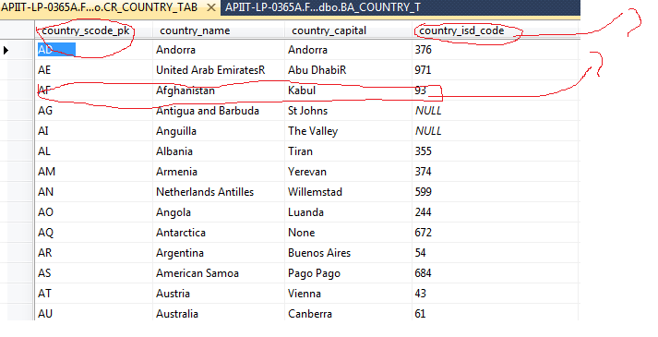T
For LO (4) DATABASE SCHEMA OR DATA DICTIONARY
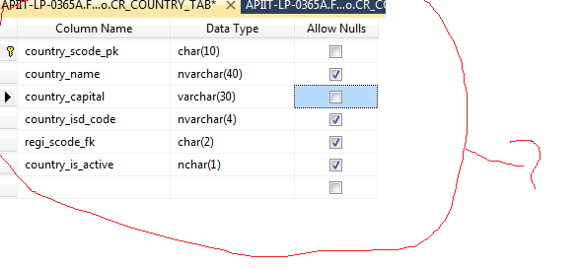
MS SQL Server Management Studio 2008 or 2012 or 2014 or 2017 or 2019

